COVID CHATBOT

Creating an interactive QnA based chatBot on a website regarding covid

STEPS INVOLVED:

Create a new resource then create a QnA maker with name QnAchatbot123



Go to Microsoft Azure portal, create a resourse group (my resource group's name is QnAchat123)

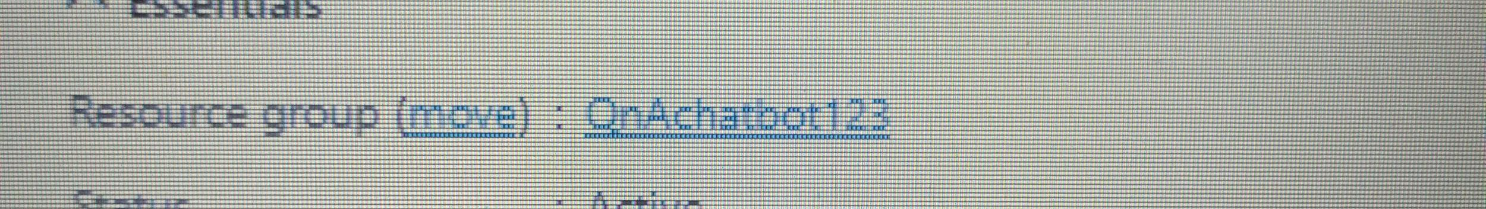

After the. Deployment of QnA maker is completed,

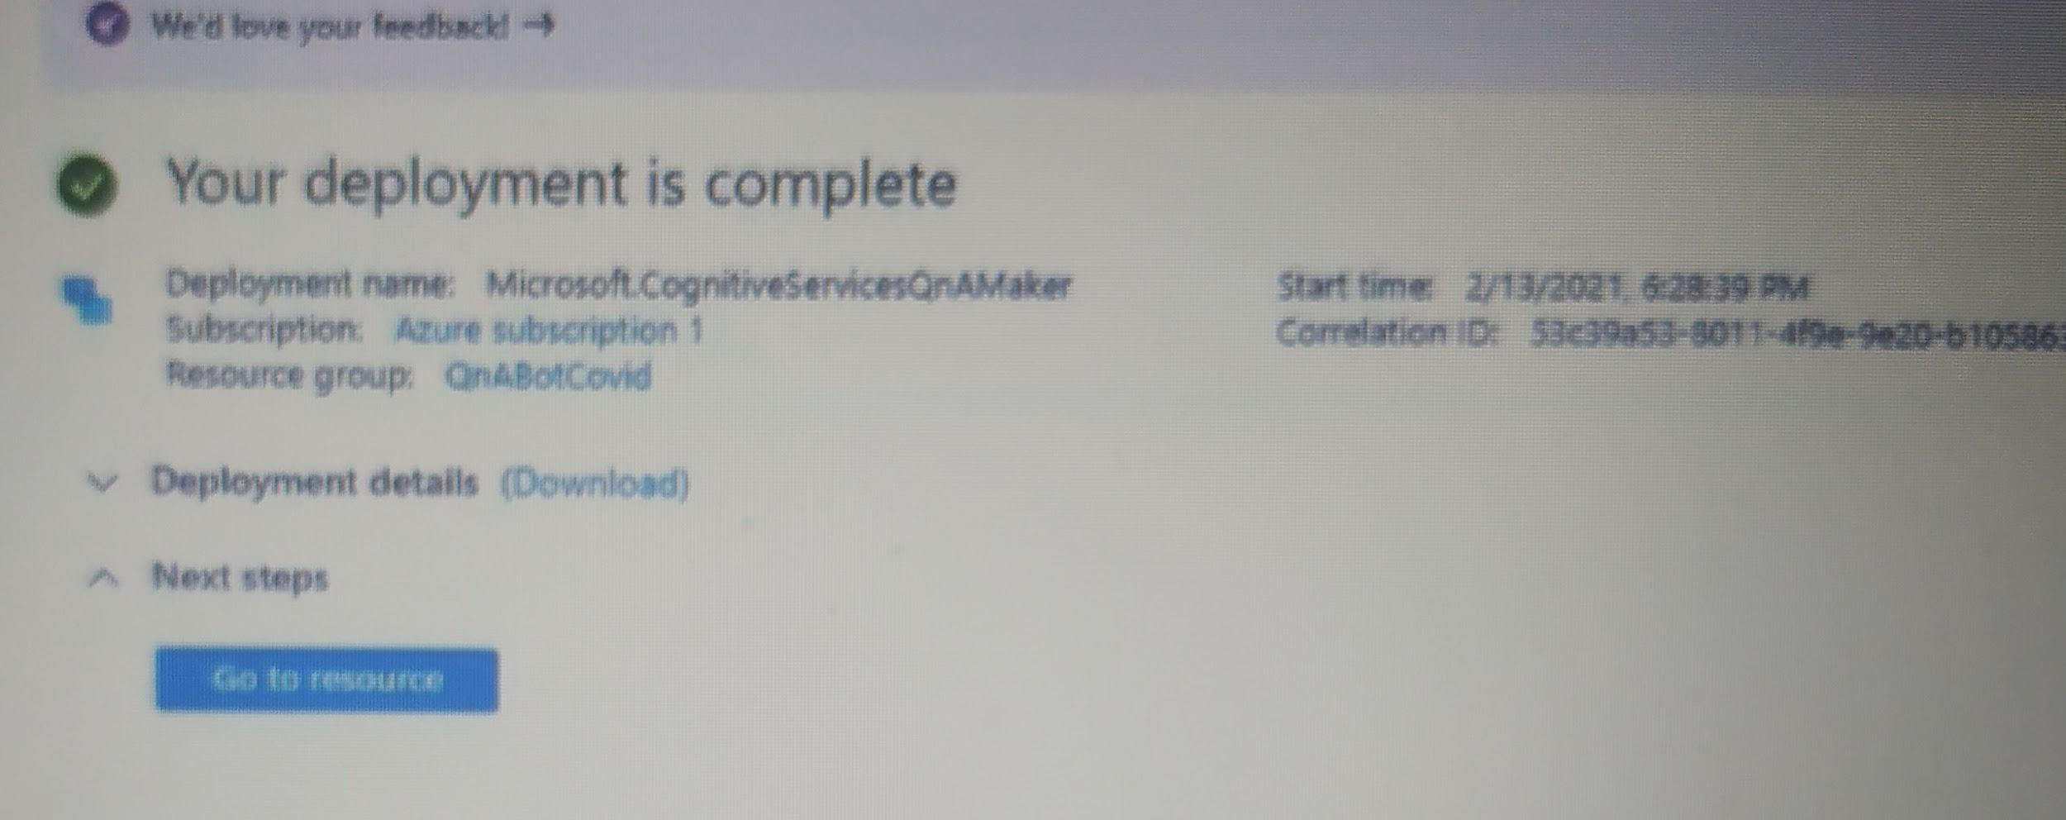

Go to resource and go to step 2

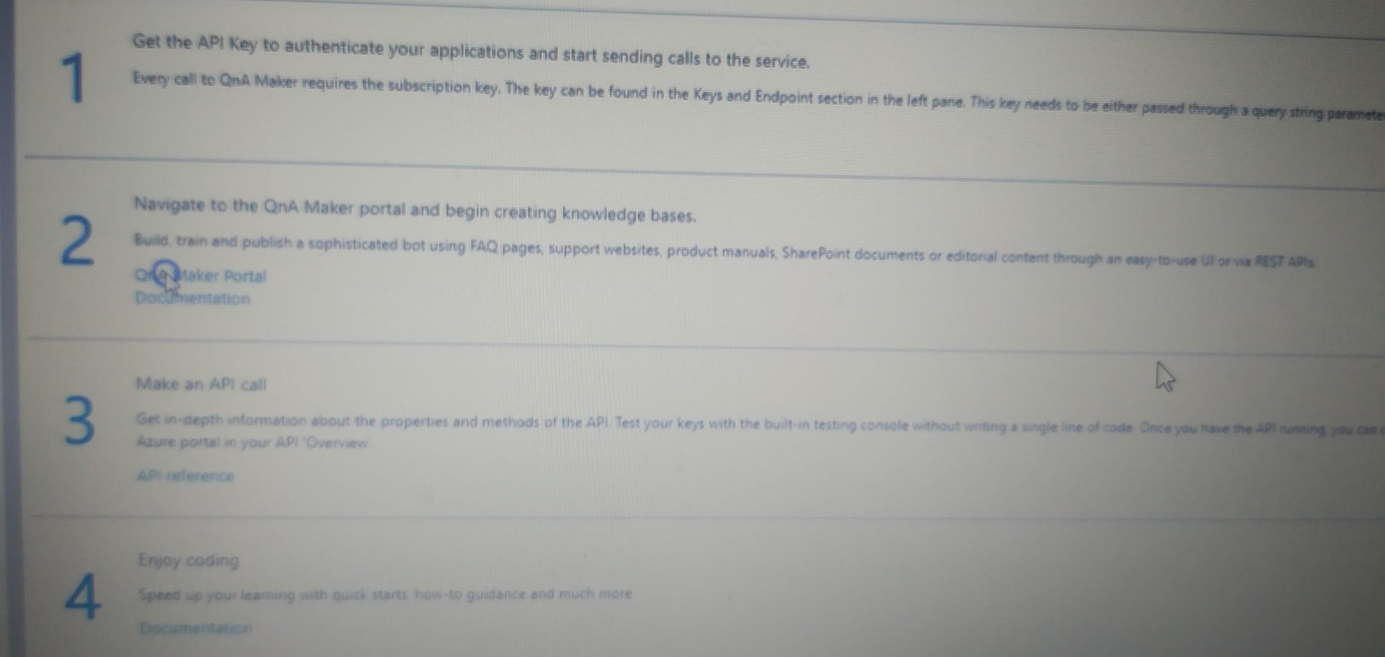

Create a knowledge base

# 

Create the knowledge base with extra required QnA pairs and test it.

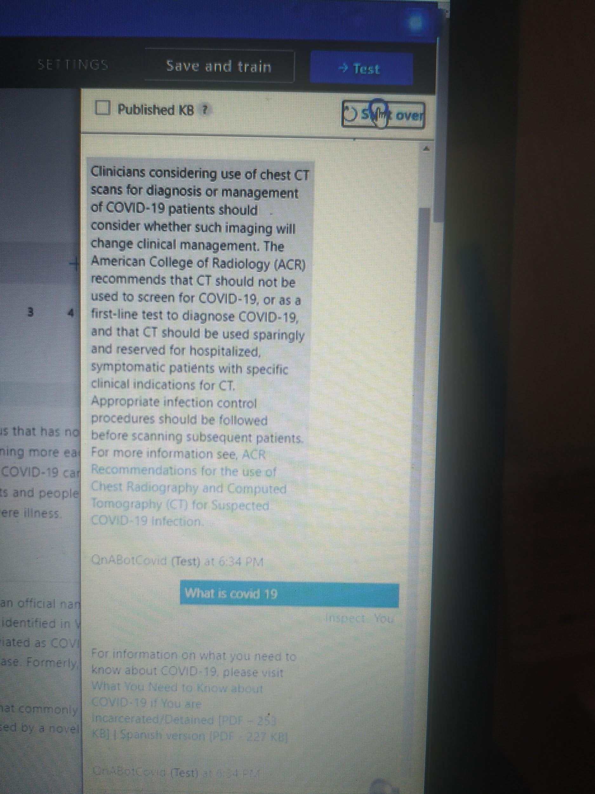

After the knowledge base creation, publish the QnA bot123 then click on create Bot which will create Web App Bot then publish it.

Copy the embed code

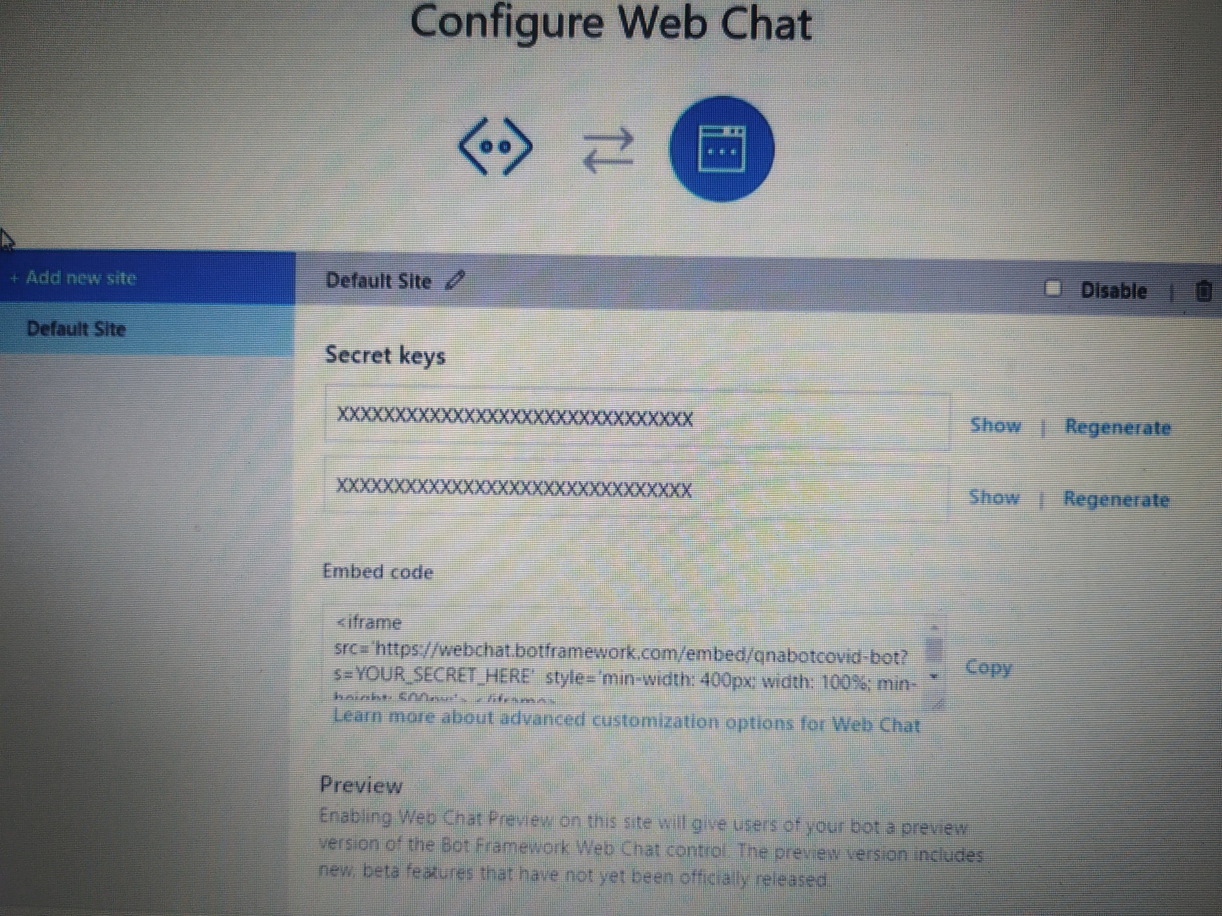

Go to Google Sites and create the we site by editing the embed code with the copied embed code and adding the secret keys. Then publish the Site.

Here are the few sample of the few question and answer pairs.

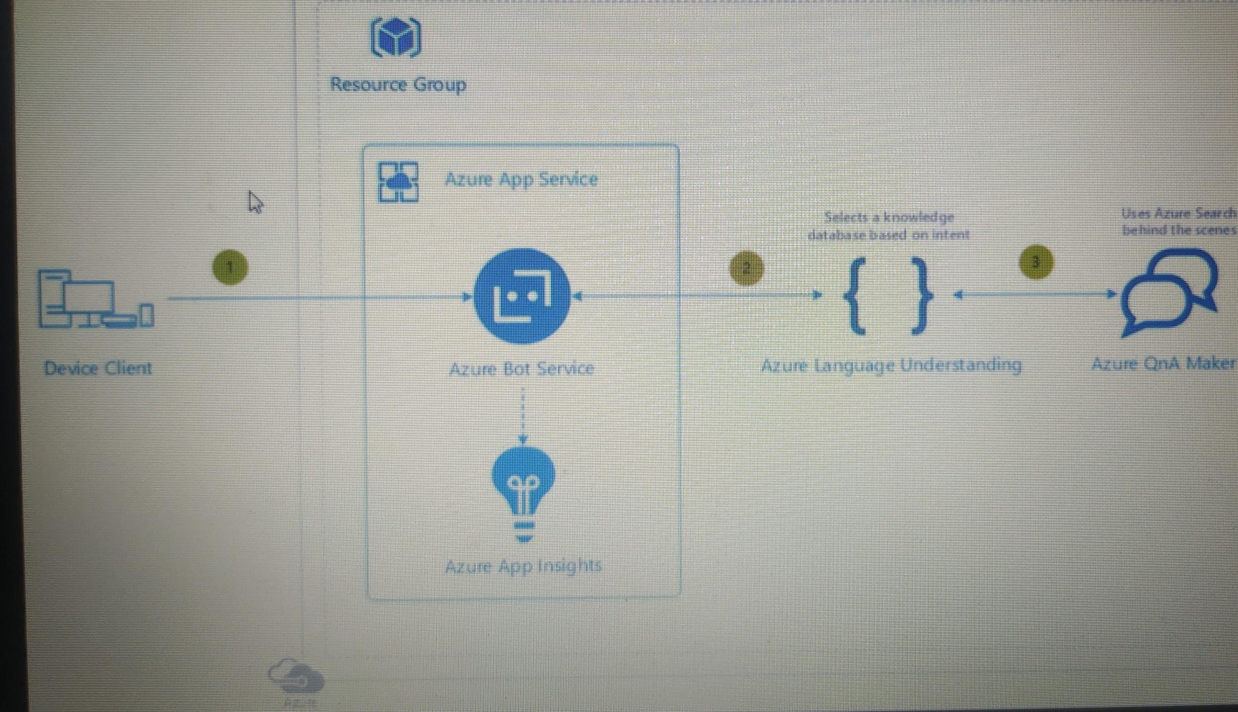

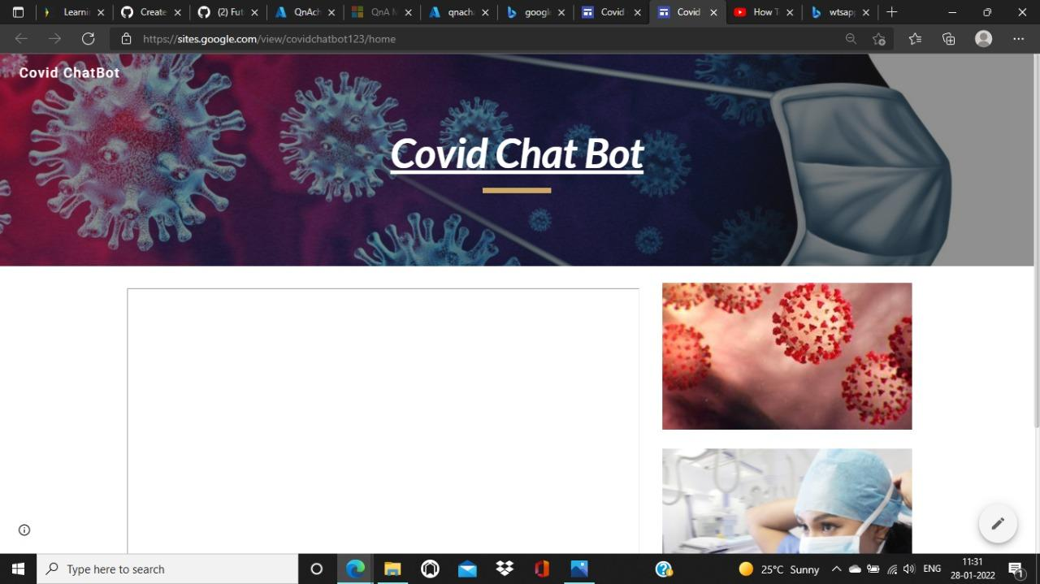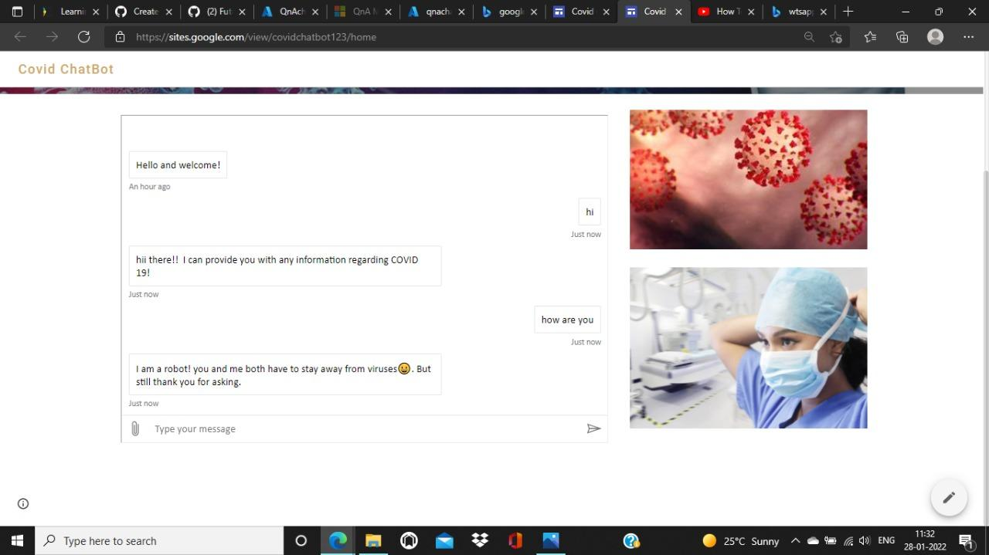

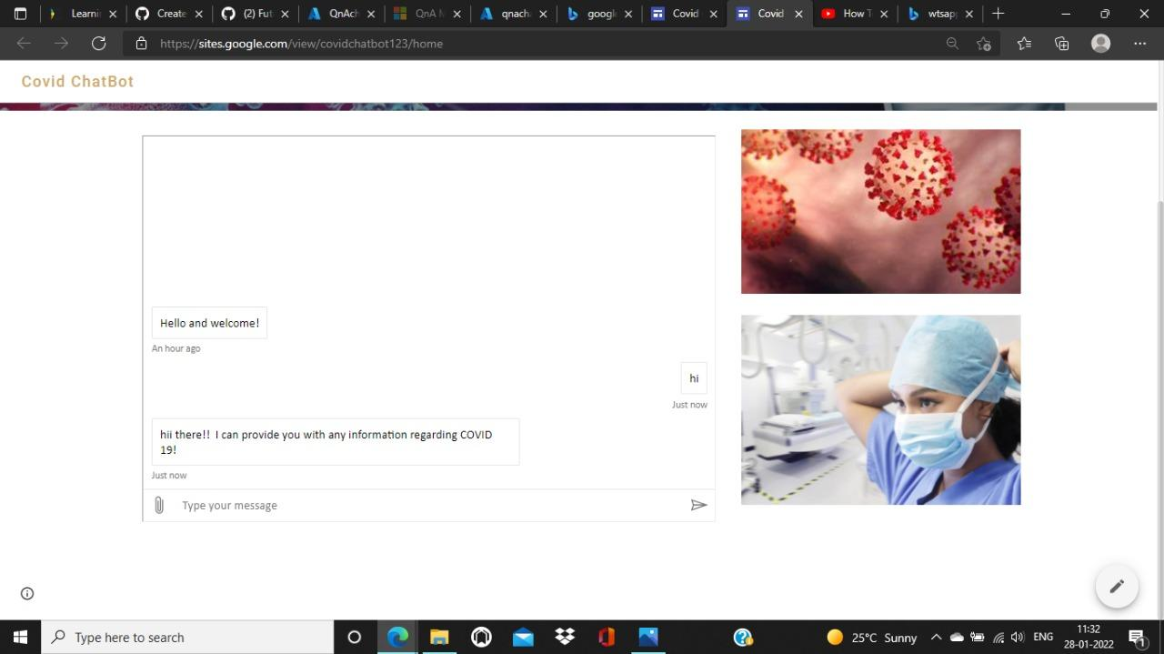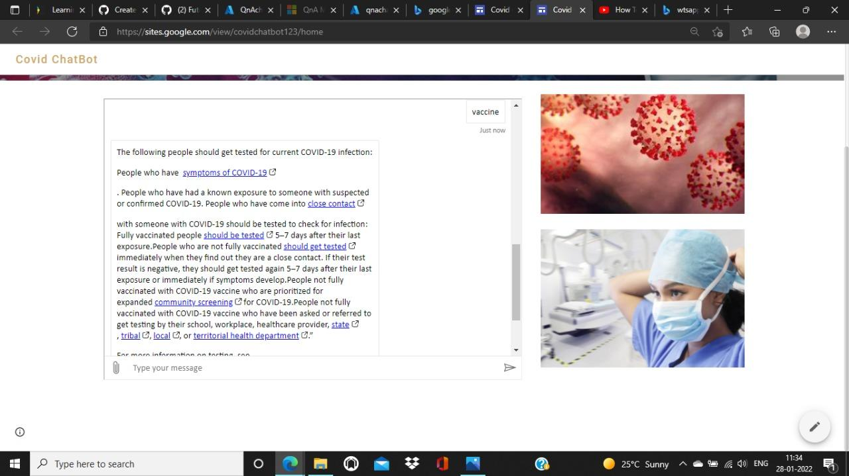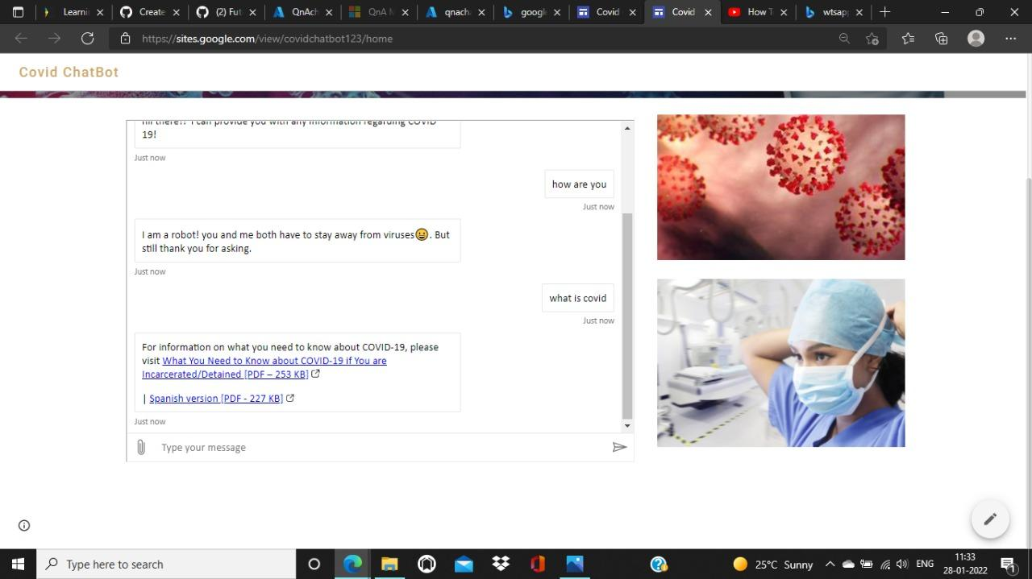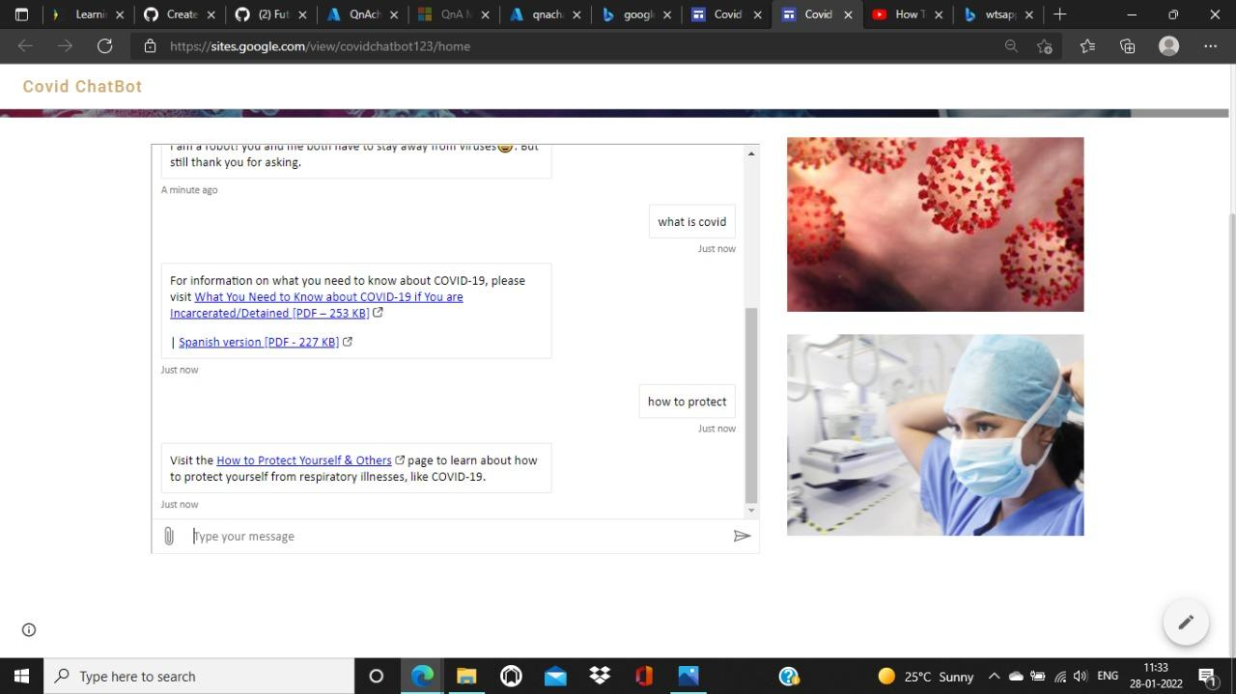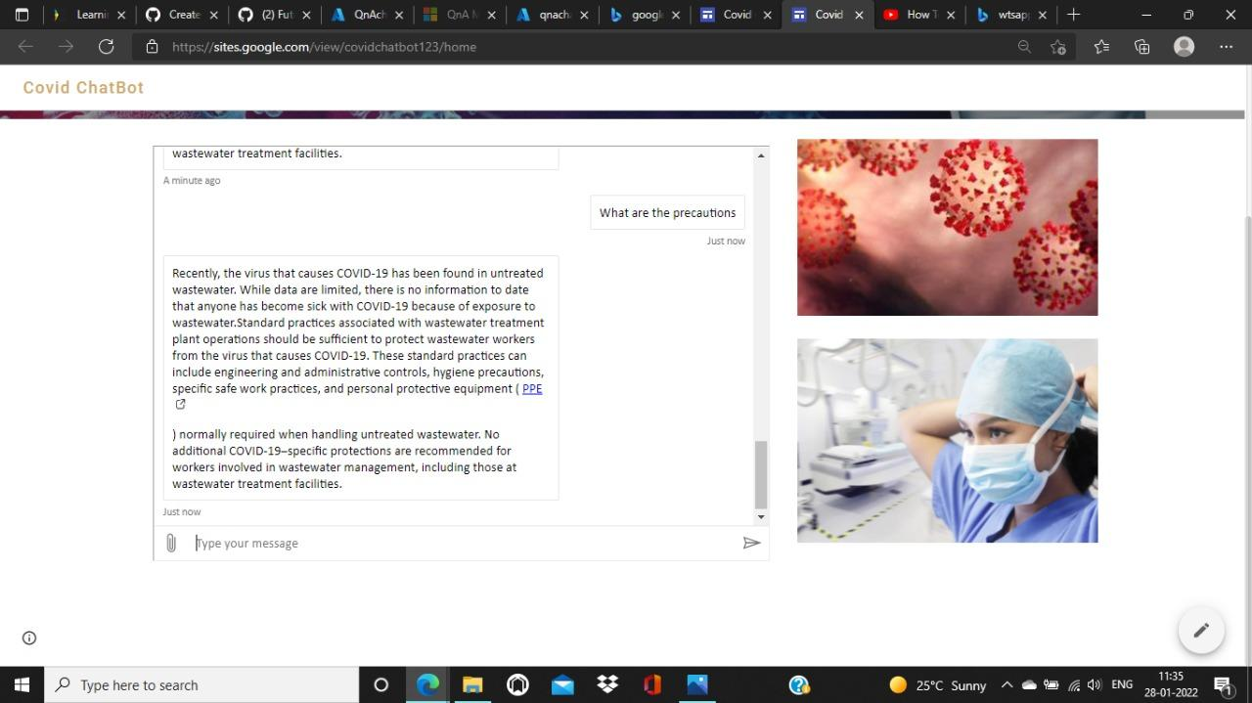

Many more hundreds of questions and replies can be extracted.